SEMESTER :-01

# HTML (index.html)

Q1:- Input:-

<!DOCTYPE html>

<html lang="en">

<head>

<meta charset="UTF-8">

<meta http-equiv="X-UA-Compatible" content="IE=edge">

<meta name="viewport" content="width=device-width, initial-scale=1.0">

<title>Document</title>

</head>

<body>

<h1>Hello World</h1>

<p>Lorem ipsum dolor sit amet consectetur adipisicing elit. Quisquam, quaerat. Quisquam, quaerat. Quisquam, quaerat. Quisquam, quaerat. Quisquam, quaerat. Quisquam, quaerat. Quisquam, quaerat. Quisquam, quaerat. Quisquam, quaerat.</p>

</body>

</html>

Output:-

Hello World

Lorem ipsum dolor sit amet consectetur adipisicing elit. Quisquam, quaerat. Quisquam, quaerat. Quisquam, quaerat. Quisquam, quaerat. Quisquam, quaerat. Quisquam, quaerat. Quisquam, quaerat. Quisquam, quaerat. Quisquam, quaerat.

<https://htmlcssjs.libraryprogramm.repl.co/>

Q2:- Input:-

<!DOCTYPE html>

<html lang = "en">

<head>

<meta charset = "UTF - 8">

<meta http-equiv="X-UA-Compatible" conent="IE=edge">

<meta name="viewport" content="width=device-width,initial-scale=1.0">

<title>Assignment 1 Q1.FAMILY MEMBERS NAME USING HEADING TAG</title>

</head>

<body>

<h1> FAMILY MEMBERS NAME </h1>

<h2> JYOTI KALIDAS DURANE</h2>

<h3> KALIDAS BANDU DURANE</h3>

<h4> AKASH KALIDAS DURANE</h4>

<h5> OMKAR KALIDAS DURANE</h5>

<h6> POOJA</h6>

</body>

</html>

OUTPUT:-

**FAMILY MEMBERS NAME**

**JYOTI KALIDAS DURANE**

**KALIDAS BANDU DURANE**

**AKASH KALIDAS DURANE**

**OMKAR KALIDAS DURANE**

**POOJA**

**file:///C:/Users/Student.DESKTOP-A5JQ0V1/Desktop/AKD.html**

**Q3:- Input:-**

**<!DOCTYPE html>**

**<html lang = "en">**

**<head>**

**<meta charset = "UTF - 8">**

**<meta http-equiv="X-UA-Compatible" conent="IE=edge">**

**<meta name="viewport" content="width=device-width,initial-scale=1.0">**

**<title>Assignment 1 Q2.CRICKETERS NAME IN BOLD ITALIC & UNDERLINE</title>**

**</head>**

**<body>**

**<h1> CRICKETERS NAME IN BOLD ITALIC & UNDERLINE</h1>**

**<h3><b> VIRAT</b><br>**

**<u> SACHINE</u>**

**<i> BRAVO</i>**

**</h3>**

**</body>**

**</html>**

**OUTPUT:-**

# CRICKETERS NAME IN BOLD ITALIC & UNDERLINE

### VIRAT SACHINE *BRAVO*

**file:///C:/Users/Student.DESKTOP-A5JQ0V1/Desktop/AKD2.html**

**Q4:- Input:-**

<!DOCTYPE html>

<html lang = "en">

<head>

<meta charset = "UTF - 8">

<meta http-equiv="X-UA-Compatible" conent="IE=edge">

<meta name="viewport" content="width=device-width,initial-scale=1.0">

<title>Assignment 1 Q3.FAMILY MEMBERS NAME without USING HEADING TAG</title>

</head>

<body>

<font size="3"<b> FAMILY MEMBERS NAME </b></font><br>

<font size="4"<u>JYOTI KALIDAS DURANE</u></font><br>

<font size="5"<i>KALIDAS BANDU DURANE</i></font><br>

<font size="6"<u>AKASH KALIDAS DURANE</u></font><br>

<font size="7"<u> OMKAR KALIDAS DURANE</u></font><br>

<h6> POOJA</h6>

</body>

</html>

Output:-

**FAMILY MEMBERS NAME**   
JYOTI KALIDAS DURANE  
*KALIDAS BANDU DURANE*  
AKASH KALIDAS DURANE  
OMKAR KALIDAS DURANE

**POOJA**

<file:///C:/Users/Student.DESKTOP-A5JQ0V1/Desktop/AKD3.html>

Q1] Input: -

<!DOCTYPE html>

<html lang="en">

<head>

<meta charset="UTF-8">

<meta http-equiv="X-UA-Compatible" content="IE=edge">

<meta name="viewport" content="width=device-width, initial-scale=1.0">

<title>Set A: - Q1]</title>

</head>

<body bgColor="black" text="blue">

<font size="10"><b> JYOTI KALIDAS DURANE </b></font> <br>

<font size="8"><b> KALIDAS BANDU DURANE </b></font> <br>

<font size="6"><u> Cdt.AKASH KALIDAS DURANE </u></font> <br>

<font size="4"><u> OMKAR KALIDAS DURANE </u></font>

</body>

</html>

Output: -

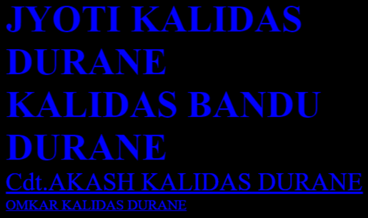

Q2] Input: -

<!DOCTYPE html>

<html lang="en">

<head>

<meta charset="UTF-8">

<meta http-equiv="X-UA-Compatible" content="IE=edge">

<meta name="viewport" content="width=device-width, initial-scale=1.0">

<title>Set A: - Q2]</title>

</head>

<body bgColor="black">

<pre>

<font size="10" color="blue"> Here is a list of Presidents of India since independence in 1947:</font>

<font size="6" color="violet"> Rajendra Prasad: January 26, 1950, to May 13, 1962 </font>

<font size="6" color="indigo"> Sarvepalli Radhakrishnan: May 13, 1962, to May 13, 1967 </font>

<font size="6" color="blue"> Zakir Husain: May 13, 1967, to May 3, 1969 </font>

<font size="6" color="green"> Varahagiri Venkata Giri (acting): August 24, 1969, to August 24, 1969 </font>

<font size="6" color="yellow"> Varahagiri Venkata Giri: August 24, 1969, to August 24, 1974 </font>

<font size="6" color="orange"> Fakhruddin Ali Ahmed: August 24, 1974, to February 11, 1977 </font>

<font size="6" color="red"> Basappa Danappa Jatti (acting): February 11, 1977, to July 25, 1977 </font>

<font size="6" color="white"> Neelam Sanjiva Reddy: July 25, 1977, to July 25, 1982 </font>

<font size="6" color="violet"> Giani Zail Singh: July 25, 1982, to July 25, 1987 </font>

<font size="6" color="green"> R. Venkataraman: July 25, 1987, to July 25, 1992 </font>

</pre>

</body>

</html>

Output: -

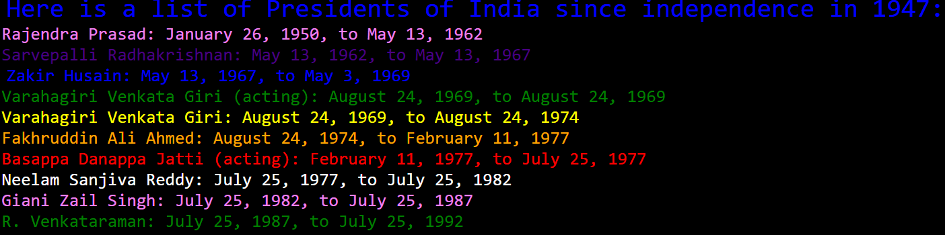

Or

<!DOCTYPE html>

<html lang="en">

<head>

<meta charset="UTF-8">

<meta name="viewport" content="width=device-width, initial-scale=1.0">

<title>India's Presidents</title>

</head>

<body>

<h1>India's Presidents</h1>

<p style="color: blue;">Dr. Rajendra Prasad (1950-1962)</p>

<p style="color: green;">Dr. S. Radhakrishnan (1962-1967)</p>

<p style="color: red;">Zakir Hussain (1967-1969)</p>

<p style="color: purple;">V. V. Giri (1969-1974)</p>

</body>

</html>

Q3] Input: -

<!DOCTYPE html>

<html lang="en">

<head>

<meta charset="UTF-8">

<meta name="viewport" content="width=device-width, initial-scale=1.0">

<title>Indian Cricket Team</title>

</head>

<body>

<h1>Indian Cricket Team Players</h1>

<p style="font-weight: bold;">Virat Kohli</p>

<p style="font-style: italic;">Rohit Sharma</p>

<p style="text-decoration: underline;">Jasprit Bumrah</p>

<p style="font-weight: bold; font-style: italic;">KL Rahul</p>

<p style="font-weight: bold; text-decoration: underline;">Ravindra Jadeja</p>

<p style="font-style: italic; text-decoration: underline;">Shikhar Dhawan</p>

</body>

</html>

Output: -

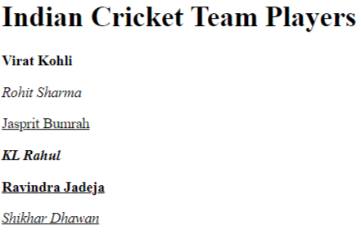

Q4] Input: -

<!DOCTYPE html>

<html lang="en">

<head>

<meta charset="UTF-8">

<meta name="viewport" content="width=device-width, initial-scale=1.0">

<title> ecpression </title>

</head>

<body>

<h1>polinimal Expression </h1>

<p style="font-weight: bold;">a<sub>0</sub> + a<sub>1</sub>x + a<sub>2</sub>x<sup>2</sup> + a<sub>3</sub>x<sup>3</sup></p>

</body>

</html>

Output: -

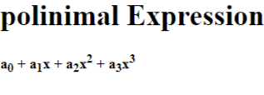

Set B: - Input: -

<html>

<title> MODERN COLLEGE FIRST WEBSITE</title>

<style>

body { background-image: url('b.jpg');

background-repeat: no-repeat;

background-size: cover;

}

</style>

<body>

<header>

<h2><b> Modern College of Arts, Science and Commerce </b></h2>

<div>

<h5><i><b> Address: GRGW+F5J, Modern Engineering College Rd, Sumukh Society, Shivajinagar, Pune, Maharashtra 411005 </b></i></h5>

</div>

</header>

<main>

<br>

<marquee behavior="scroll" direction="left"><font size="3" color="blue">FOR NCC ENROLLMENT CLICK THE IMAGE GIVEN BELOW</font></marquee>

<br><br>

<font size="6" color="red"><ul> Courses Offered: - </font>

<li><font size="5" color="blue"><i> BCA </i></font></li>

<li><font size="5" color="yellow"><i> INFORMATION TECHNOLOGY </i></font></li>

<li><font size="5" color="brown"><i> Science </i></font></li>

<li><font size="5" color="crimson"><i> MCA </i></font></li>

<li><font size="5" color="MediumVioletRed"><i><b> MASTERS OF COMPUTER APPLICATIONS </b></i></font></li>

<li><font size="5" color="black"><i> MASTERS IN BUSINESS ADMINISTRATION </i></font></li>

<li><font size="5" color="blue"><i> B/A </i></font></li>

<li><font size="5" color="blue"><i> ANIMATION </i></font></li>

<li><font size="5" color="indigo"><i> DESIGN </i></font></li>

<li><font size="5" color="red"><i> BACHLOR OF BUSINESS </i></font></li>

</ul>

</main>

<br><hr><hr>

<article>

<font size="5" color="blue"><b> For NCC Enrolement click on the logo below </b></font><br>

<a href="file:///C:/Users/durne_/OneDrive/Desktop/NCC_ENROLLMENT.html" target="main">

<img src="NCClogo.png" height="90" weidth="90">

</a>

</article>

<hr><hr>

<br> <br>

<footer>

<img src="https://content3.jdmagicbox.com/comp/pune/s7/020pxx20.xx20.001128285262.l6s7/catalogue/modern-college-of-arts-science-and-commerce-shivaji-nagar-pune-colleges-1zgwxuk.jpg?clr=" alt="modern college img" height="100",weidth="100"> <br>

<pre><u> For more information contact:- 7619447817(Cdt.Akash Kalidas Durane) </u>

<h4> C-18 Sunshine Terraces Priyadarshani Nagar Old Sangvi Pune City - Pune - Maharashtra 411027 </h4>

</pre>

</footer>

</body>

</html>

## AND 2nd WEBSITE

<html>

<title> NCC Enrollement form </title>

<style>

body{background-image: url('flag.jpg');

background-repeat: no-repeat;

background-size: cover;

background-color: black;

}

</style>

<body>

<br>

<header><pre> <font size="6" color="red"><b> Fill The Following Details For Enrollement :- </b></font></pre></header>

<hr><hr>

<main>

<form action="/action.php">

<br><br><br>

<input type ="radio" value="THE ARMY WING" name="WING"><font size="4" color="red">THE ARMY WING</font>

<input type ="radio" value="THE NAVY WING" name="WING"><font size="4" color="WHITE"><b>THE NAVY WING<b></font>

<input type ="radio" value="THE AIR FORCE WING" name="WING"><font size="4" color="lightblue">THE AIR FORCE</font><br>

<br><br>

<input type ="text" placeholder="ENTER YOUR NAME"><br>

<br><br>

<input type ="text" placeholder="COURSE"><br>

<br><br>

<input type ="text" placeholder="ROLL NO."><br>

<br><br>

<input type ="text" placeholder="DIVISION"><br>

<br><br>

<input type ="text" placeholder="CLASS"><br>

<br><br>

<select name="blood">

<option value="choose">choose</option><br>

<option value="A+">A+</option><br>

<option value="A-">A-</option><br>

<option value="B+">B+</option><br>

<option value="B-">B-</option><br>

<option value="O+">O+</option><br>

<option value="O-">O-</option><br>

<option value="AB+">AB+</option><br>

<option value="AB-">AB-</option><br>

</select>

<br><br><input type="submit" value="SUBMIT"><br>

<br>

<div>

<font size="6" color="orange"><i> FOR NCC SELECTION PROCEDURE WATCH THE VIDEO BELOW </i></font>

<iframe width="560" height="315" src="https://www.youtube.com/embed/Pq8sHHXa304?si=pQoYa2lGjT3wbJCH" title="YouTube video player" frameborder="0" allow="accelerometer; autoplay; clipboard-write; encrypted-media; gyroscope; picture-in-picture; web-share" allowfullscreen></iframe>

</div>

</form>

</main>

<hr><hr>

<footer> <img src="https://content3.jdmagicbox.com/comp/pune/s7/020pxx20.xx20.001128285262.l6s7/catalogue/modern-college-of-arts-science-and-commerce-shivaji-nagar-pune-colleges-1zgwxuk.jpg?clr=" alt="modern college img" height="100",weidth="100"> <br>

<pre><u> For more information contact:- 7619447817(Cdt.Akash Kalidas Durane) </u>

<h4> C-18 Sunshine Terraces Priyadarshani Nagar Old Sangvi Pune City - Pune - Maharashtra 411027 </h4>

</pre>

</footer>

</body>

</html>

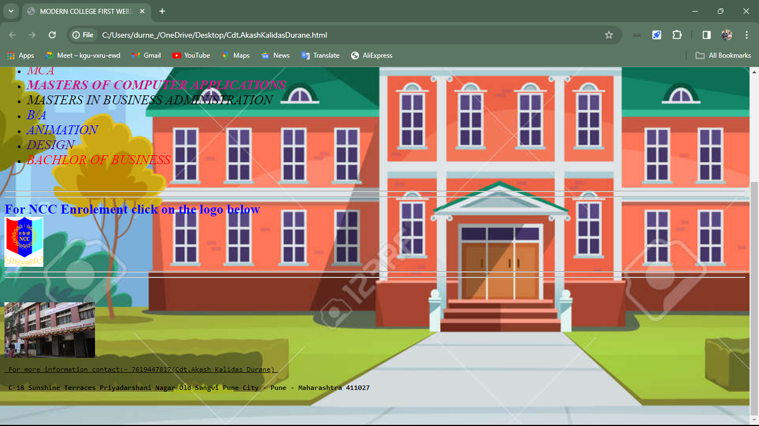Output: -

## SECOND WEBSITE

SET C: -

Q1] Input: -

<html>

<head>

<title> SAMPLE CODE </title>

<link rel="stylesheet" href="file:///C:/Users/Admin/Desktop/SAMPLE.css">

</head>

<body>

<h1> ALL EXERCISE </h1>

<h3> Set B:- </h3>

<ul>

<li> COFFEE </li>

<li> TEA </li>

</ul>

<br>

<ul type="square">

<li> BLACK TEA </li>

<li> GREEN TEA </li>

</ul>

<br>

<ol type="a" >

<li> LEMOM TEA </li>

<li> GINGER TEA </li>

<li> MASALA TEA </li>

</ol>

</body>

</html>

STYLE.css

h1 {

color : white;

}

body {

background-color : black;

}

li {

color : white;

}

Output: -

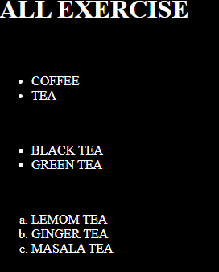

Q2: - Input: -

<html>

<head>

<title> SAMPLE CODE </title>

<link rel="stylesheet" href="file:///C:/Users/Admin/Desktop/SAMPLE.css">

</head>

<body>

<h1> ALL EXERCISE </h1>

<h3> Set B:- </h3>

<ul>

<li> COFFEE

<ul>

<li> Flat white </li>

<li> Expresso </li>

<li> Vienna </li>

<li> Affogato </li>

</ul>

</li>

</ul>

<br>

<br>

<ul type="square">

<li> SOUPS

<ul>

<li> Baby corn soup </li>

<li> brocconi and cheddar soup </li>

<li> vegetable and manchow soup </li>

<li> corn and miso soup </li>

</ul>

</li>

</ul>

</body>

</html>

CSS: -

*{

background-color: black;

}

ul {

color : white;

}

h1,h3 {

color : blue;

}

Output: -

